**Artificial|Final Boss:**

**Health:** 20000

**Phase switch:** 70%,30%,5% health left.

**Damage:** See “Attack”

**Phase 1(100% -> 70%):**

**Aesthetic**:

* Red core with a silver shell that covers it. Sits in the middle of the room.

**Boss Room:**



**Music:**

* **Low but epic**

**Movement:**

* Doesn’t move

**Mechanics:**

* Boss is invulnerable while the 4 character enemies are alive but is vulnerable while firing the lasers.

**Attack:**

* **Attack 1**: Spawn Enemies
  + **Range:** N/A
  + **Damage:** N/A
  + **Effect:** Spawns 4 Player character enemies with random uncommon weapons. Basic Captain AI.
* **Attack 2**: Quad Laser
  + **Range:** Long
  + **Damage:** 20%(per second)
  + **Effect:** Fires for laser beams in the four cardinal directions and rotate 90 degrees. This happens after killing the 4 player character enemies.

**Phase 2:(70% -> 30%)**

**Aesthetic**:

* Bosses shell breaks off to reveal the pulsing red heart that can float around and attack.

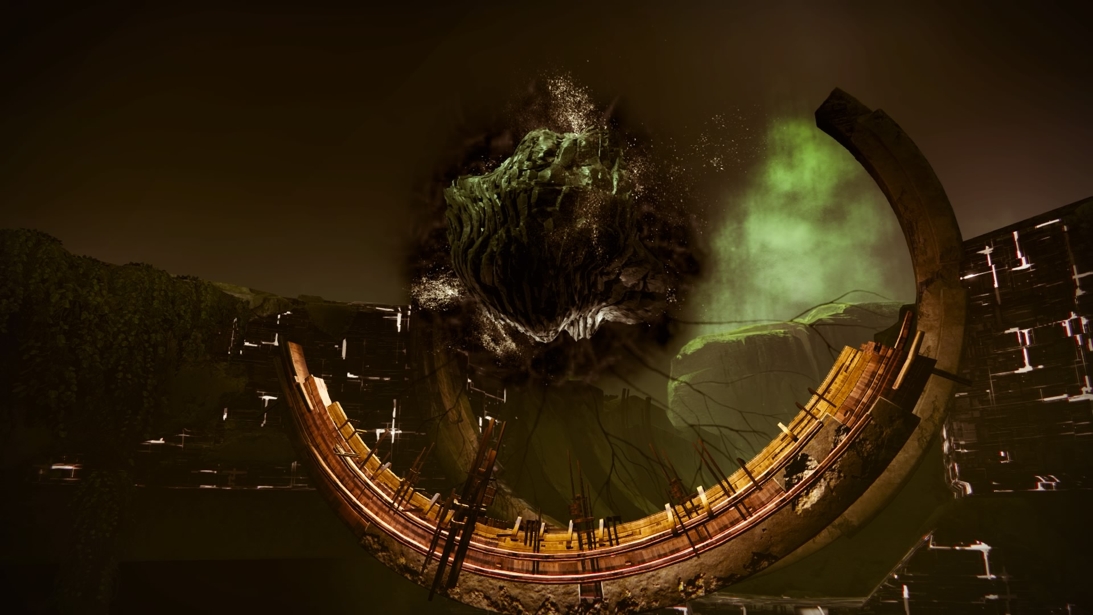

*(Art From Google)*

**Boss Room:**



**Music:**

* **Epic pretty typical.**

**Movement:**

* Floats fast around the map.

**Mechanic:**

* When the shell is broken, the heart releases a thin cloud of red nanomites into the entire area.

**Attack:**

* **Attack 1**: Basic Attack
  + **Range:** long
  + **Damage:** 10%(per hit) 3 bolt burst
  + **Effect:** Sends out 3 nanomite bolts at the player.
* **Attack 2**: Quad Laser
  + **Range:** Long
  + **Damage:** 20%(per second)
  + **Effect:** Pauses and uses the beam attack from phase 1.
* **Attack 3**: I created you, I can destroy you dammit
  + **Range:** Unavoidable
  + **Damage:** 100%(Kills the player)
  + **Effect:** The boss with pulse for a long time about 10 seconds, the large alarm increasing as the boss ramps up in power. After 10 seconds the boss will send out a huge AoE and kill the player. No matter what. The only way to stop it is to deal enough damage to the boss to stun it.
  + <https://www.youtube.com/watch?v=5I00r0LpsOs>
  + ^Almost exactly like this.

**Phase 3:(30% -> 5%)**

**Aesthetic**:

* Pulsing red heart that can float around and attack, but much more erratic with little particle effects flaking off.



*(Art From Google)*

**Boss Room:**



**Music:**

* **Extremely frantic music.**

**Movement:**

* Floats fast around the map.

**Mechanic:**

* When the shell is broken, the heart releases a thin cloud of red nanomites into the entire area. Still there. ;)

**Attack:**

* **Attack 1**: ElectroPort
  + **Range:** Very short
  + **Damage:** 20%(per hit)
  + **Effect:** Teleports to the player and electrocutes them at close range.
* **Attack 2**: Dash
  + **Range:** Medium
  + **Damage:** 40%(per second)
  + **Effect:** Pauses for 3 seconds and dashes towards the player. If it connects it deals heavy damage.

**Phase 4:(5% -> 0%)**

**Aesthetic**:

* Pulsing red heart that can float around and attack, but much more erratic with little particle effects flaking off.



*(Art From Google)*

**Boss Room:**



**Music:**

* **Extremely frantic music.**

**Movement:**

* Teleports to the middle of the room and pauses.

**Mechanic:**

Uses the attack below but has a long wind up. The player must kill it before they die.

* **Attack 1**: I created you, I can destroy you dammit
  + **Range:** Unavoidable
  + **Damage:** 100%(Kills the player)
  + **Effect:** The boss with pulse for a long time about 20 seconds, the large alarm increasing as the boss ramps up in power. After 20 seconds the boss will send out a huge AoE and kill the player. No matter what. The only way to stop it is to deal enough damage to the boss to stun it.
  + <https://www.youtube.com/watch?v=5I00r0LpsOs>
  + ^Almost exactly like this.